
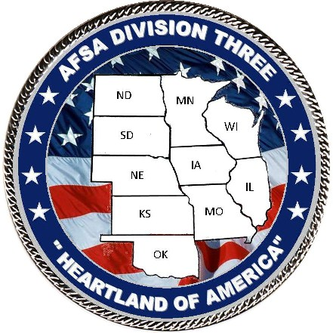

Air Force Sergeants Association
2018 Division 3 Conference

All Division 3 Chapter Members,

Our 2018 Division 3 Conference will be held at the Drury Plaza Hotel Broadview, 400 W. Douglass Ave, Wichita, KS 67202. The dates are 5-7 April 2018. Please join us and show your support for your Association. Our host chapter is the “Sunflower Chapter” Chapter 972, Wichita, KS.

Please make your hotel reservations early and get your conference registration form sent in before the deadline. The deadline for conference registration is 18 March at $105.00. After that date, any late registrations will be $120. The room rate is $119 + 18.25% tax per room, per night. The hotel registration rate ends 9 March. After that date rooms will revert to full price and not guaranteed.

This year the Opening/Welcoming get-together on Thursday evening will be an Air Capital of the World theme (casual dress). Please come armed with aviation themed flair, as Wichita has been dubbed the Air Capital of the World. The Opening Ceremony Friday will begin after breakfast on your own. The same goes for Saturday morning.

If you have any special meal or room requests, please indicate that on your registration form. Every effort will be made to honor your requests.

If you have any further questions or concerns, please feel free to contact me at the address or phone number listed on the registration form. My email address is heidi_lease@yahoo.com.

Yours in AFSA Spirit,
Heidi M. Hunter

Heidi Hunter
Conference Manager
AFSA Divisions 3 2018 Conference Registration Form
  - April 2018

1. General Information (PLEASE PRINT OR TYPE ALL INFORMATION)

Name____________________________________Address_________________________________________________

City___________________________State_______ Zip Code_________ Phone (___ ) ___________ Chapter_______

Email Address ____________________________________________

2. Membership/Attendance Status (Check all items that apply)

AFSA________Chief Delegate______Delegate_____International Officer______ Division Officer __________

Chapter Officer_____Member____Guest____ Airman Award Nominee_______ NCO Award Nominee ______
3. Conference Registration for All Events
PRE-REGISTRATION DEADLINE – 18 MARCH 2018
Complete this section if you will be attending all scheduled events – Please indicate any special dietary requirements.
Registration fee includes: Thursday Presidents Reception, Friday Lunch, coffee breaks, and Saturday Honors Banquet.

I’m Pre-Registering PRIOR to 18 March 2018 for all events Number Attending_____@ $105.00 = Total $________

I’m Late-Registering AFTER 18 March 2018 Number Attending____@ $120.00 = Total $________

4. Conference Registration for Individual Events
Complete this section if you will only be attending individual events and not the entire conference

I will attend:
President’s Reception on Thursday (Marinated Grilled Chicken and Beef Tips) ___ @ $23.00 each = Total $________
Friday Luncheon (Deli style croissant sandwich/assorted chips/pasta) ___ @ $12.00 each = Total $________
Honors Banquet Saturday (Herb-Crusted Salmon and Marinated Top Sirloin) ___ @ $32.49 each = Total $________

5. Hotel Information – Drury Plaza Hotel Broadview, 400 W. Douglass Ave, Wichita, KS 67202

- Hotel Room Rate: $119.00 + tax, 1-4 people per room, King or Double/doubles
- Please see page 3 for registration details and included amenities.
- Hotel check-in is after 3pm on the day of arrival and check-out is 11am on the day of departure.
- Please note 9 March is the last day to make hotel reservations at the guaranteed group rate.

(Reservations received after March 9, 2018 will be provided on a space-available basis at prevailing rates)

There are numerous restaurants within walking distance from the hotel.

6. Total Amount Due

Section 3 Total. This section is for people attending the entire conference Total $ ____________

Section 4 Total. This section is for people attending only portions of the conference Total $____________

7. Mail Completed Registration Form and All Fees To:

Division 3 Conference
Matthew Reichle, President Chapter 972
1721 S. Smithmoor Ct
Wichita, KS 67217
(325) 212-8426
firematt76@yahoo.com



Drury Plaza Hotel Broadview Wichita

400 West Douglas Avenue Wichita, KS 67202

Telephone: (316) 262-5000

Thank you for allowing Drury Plaza Hotel Broadview Wichita to be a part of your next great event! We are looking forward to seeing you soon and we are ready to uphold our reputation for great service & value. Rooms have been held for your group and to make reservations, please click on the link below.
https://www.druryhotels.com/Reservations.aspx?groupno=2318391

As you might have heard, The Extra’s Aren’t Extra at Drury Hotels! In addition to the great rate, here are some of the amenities your group will enjoy:

FREE HOT QUIKSTART ® Breakfast – At Drury, “hot” means fresh pancakes, scrambled eggs, biscuits & gravy, sausage and more.

FREE 5:30 KICKBACK® – From 5:30-7:00 pm each evening, kick back, relax and enjoy a rotating menu of hot foods and cold beverages.

FREE Free Long Distance - One hour every room every night.

FREE Wireless Internet Access – High speed Internet in all rooms and the lobby.

FREE Soda and Popcorn – From 3:00 pm to 10:00 pm every night in the lobby.

Plus much more!!

Please make your reservations by Friday, March 9, 2018 to receive your group rate. Reservations made after this date will be subject to prevailing rate and availability.

Reservations may also be made by calling 1-800-325-0720 and refer to your group number 2318391.

